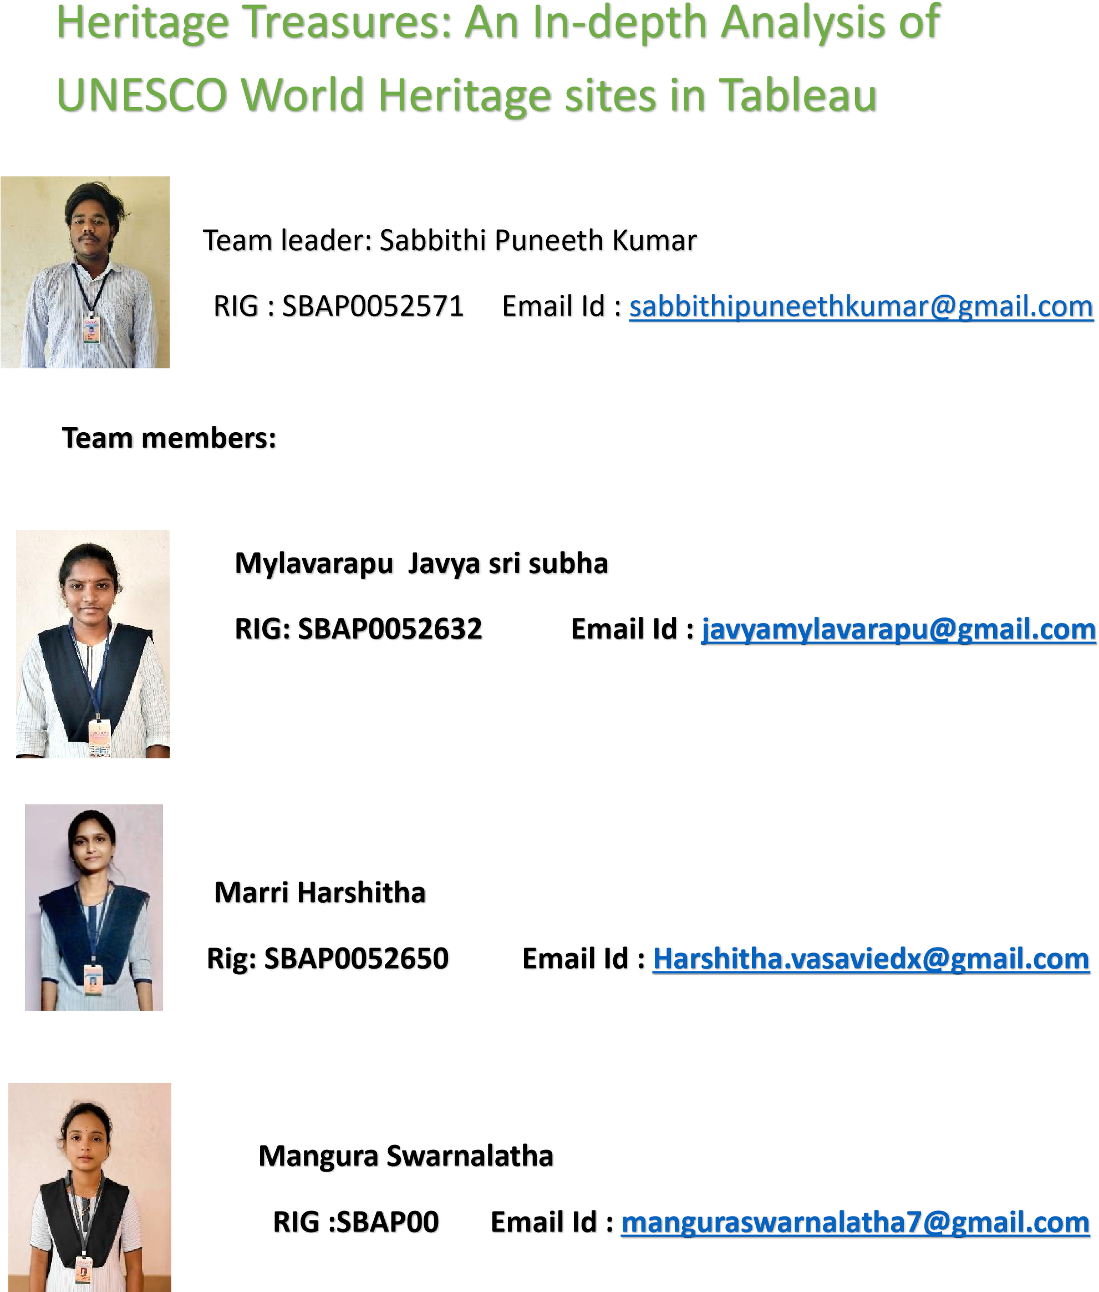



**Heritage Treasures: An In-Depth Analysis of UNESCO World Heritage Sites in Tableau**

**Category: Data Analytics with Tableau**

# skills Required: Tableau

**Project Description:**

## Scenario 1: Heritage sites by country

Scenario to the number of heritage sites it contains. This visualization will quickly identify which countries have the most UNESCO World Heritage Sites, offering a clear and comprehensive view of heritage site distribution. The key columns used for this visualization are Country and Name_en. Heritage **Scenario 2: Sites at risk**

for This pie chart will display the proportion of UNESCO World Heritage Sites listed as being in danger, segmenting the sites into 'In Danger' and 'Not in Danger' categories. This visual aids in understanding the severity of threats to world heritage sites, allowing stakeholders to focus their preservation efforts on the most vulnerable sites. The columns Danger and Name_en will be used this visualization.

## Scenario 3: Regional Inscription Trends

Regional Inscription Trends" will be included using a Line Chart. This chart will show the trend of new site inscriptions over the years, segmented by region, providing insights into which regions have seen the most growth in terms of heritage site inscriptions. By visualizing the columns Date_inscribed and Region, this chart will help identify regions with increasing heritage conservation efforts and highlight historical trends Regional Inscription Trends" will be included using a Line Chart. This chart will show the trend of new site inscriptions over the years, segmented by region, providing insights into which regions have seen the most growth in terms of heritage site inscriptions. By visualizing the columns Date_inscribed and Region, this chart will help identify regions with increasing heritage conservation efforts and highlight historical trends.

# Technical Architecture

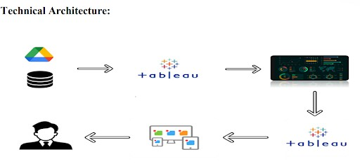

## Project Flow

To accomplish this, we have to complete all the activities listed below,

? Data Collection & Extraction from Database o Collect the dataset, o Connect data with Tableau ? Data Preparation o Prepare the Data for Visualization

? Data Visualizations o No of Unique Visualizations

? Dashboard

* Responsive and Design of Dashboard

? Story o No of Scenes of Story ? Performance Testing o Amount of Data Loaded

* Utilization of Data Filters o No of Calculation Fields o No of Visualizations/ Graphs ? Web Integration o Dashboard and Story embed with UI With Flask

? Project Demonstration & Documentation

? Projeo Record explanation Video for project end to end solution

* Project Documentation-Step by step project development procedure **c**

# Data collection & Extraction from Database

Data collection is the process of gathering and measuring information on variables of interest, in an established systematic fashion that enables one to answer stated research questions, test hypotheses, evaluate outcomes and generate insights from the Data

**Downloading the dataset**

Duration: 0.5 Hrs

Skill Tags:

Dataset[: https://www.kaggle.com/datasets/ujwalkandi/unesco-world-heritagesites/data?select=whc-sites-2019.csv](https://www.kaggle.com/datasets/ujwalkandi/unesco-world-heritage-sites/data?select=whc-sites-2019.csv)

Data contains all the meta information regarding the columns described in the CSV files

Column Description of the Dataset:

1.ID No.: Unique identifier for each UNESCO World Heritage Site.

2.Name_en: English name of the World Heritage Site.

3.Region: Geographical region where the site is located.

4.Country: Country in which the site is situated.

5.Location: Specific location of the site within the country.

6.Date_inscribed: Year the site was added to the UNESCO list.

7.Danger: Indicator of whether the site is listed as being in danger.

8.Endangered Year: Year in which the site was listed endangered 9.Date_end:The end date for the site's status as a World Heritage.

10.Category:Type of site (Cultural, Natural, Mixed).

11.Criterion 1-10: specific creteria under which the site qualifies world heritage status.

# Data Preparation

Preparing the data for visualization involves cleaning the data to remove irrelevant or missing data, transforming the data into a format that can be easily visualized exploring the preparing the data for visualization software, and ensuring the data is accurate and complete. This process helps to make the data easily understandable and ready for creating visualizations to gain insights into the performance and efficiency. Since the data is already cleaned, we can move to visualization.

**Explanation video links**

Duration: 1 Hrs

Skill Tags:

**Explanation video link 1: Data Loading**:

<https://drive.google.com/file/d/1Y941JkukrTiOOAJS4WohiqTVDcMSP29v/view?usp=sharing>

**Explanation video link 2: Data Cleaning**:

<https://drive.google.com/file/d/16Cx2C1XpatahNAHbNNVQ-4l3NgKJxJBv/view?usp=sharing>

# Data Visualization

Data visualization is the process of creating graphical representations of data to help people understand and explore the information. The goal of data visualization is to make complex data sets more accessible, intuitive, and easier to interpret. By using visual elements such as charts, graphs, and maps, data visualizations can help people quickly identify patterns, trends, and outliers in the data.

## No.of Unique Visualizations

Duration: 1 Hrs Skill Tags:

Using the given dataset, several unique visualizations can be created to analyze the dietary habits, nutritional intake, and health outcomes of college students. These visualizations include bar charts, line charts, heat maps, scatter plots, pie charts, and maps. These can be used to compare performance, track changes over time, show distribution, identify relationships, breakdown nutritional intake, provide demographic insights, inform resource allocation, and conduct geographical analysis. By leveraging these diverse visualizations, stakeholders can gain comprehensive insights into the dietary choices and health of college students, enabling data-driven decisions to promote better nutrition and overall well-being.

## visualizations Duration: 1 Hrs

Skill Tags:

Explanation link for all

visualizations: [https://drive.google.com/file/d/1wZSY11xLTglUn50D9Isc6NU2CkEiBSQz/view ?usp=sharing](https://drive.google.com/file/d/1wZSY11xLTglUn50D9Isc6NU2CkEiBSQz/view?usp=sharing)

## Activity 1.1: Countries per Region

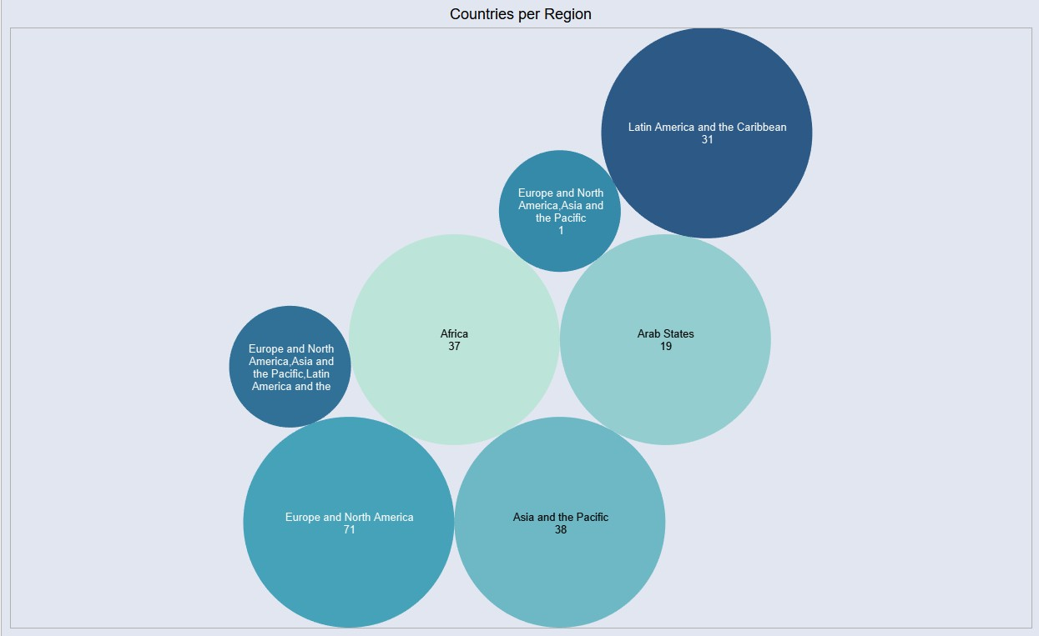

## Activity 1.2: Top 10 regions by area

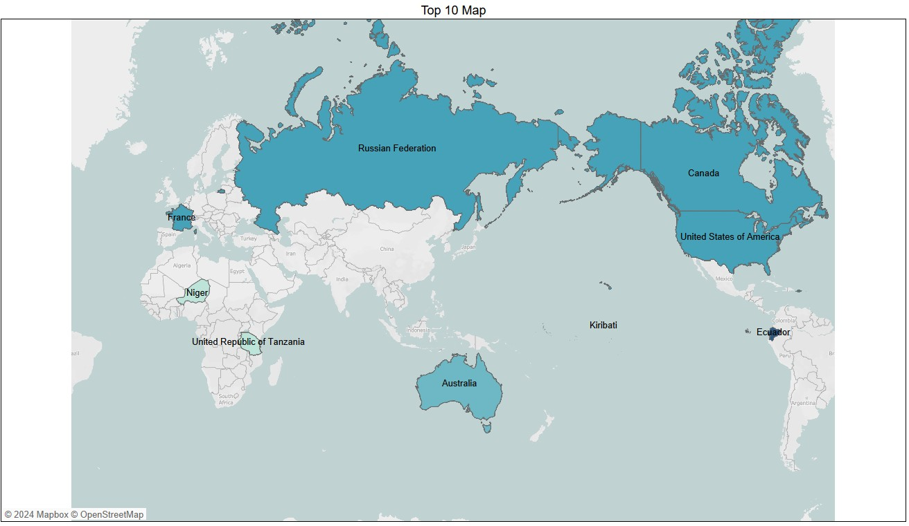

## Activity 1.3: Regions by Heritage ended

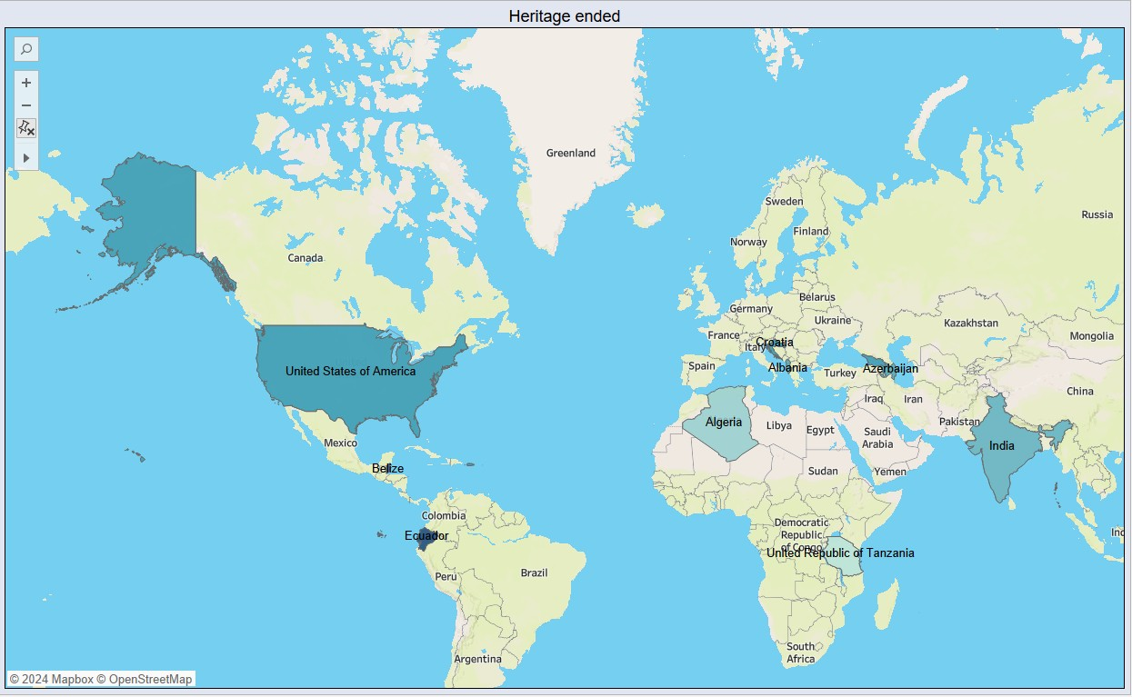

## Activity 1.4 : Top 10 Danger Sites prone to Extinction

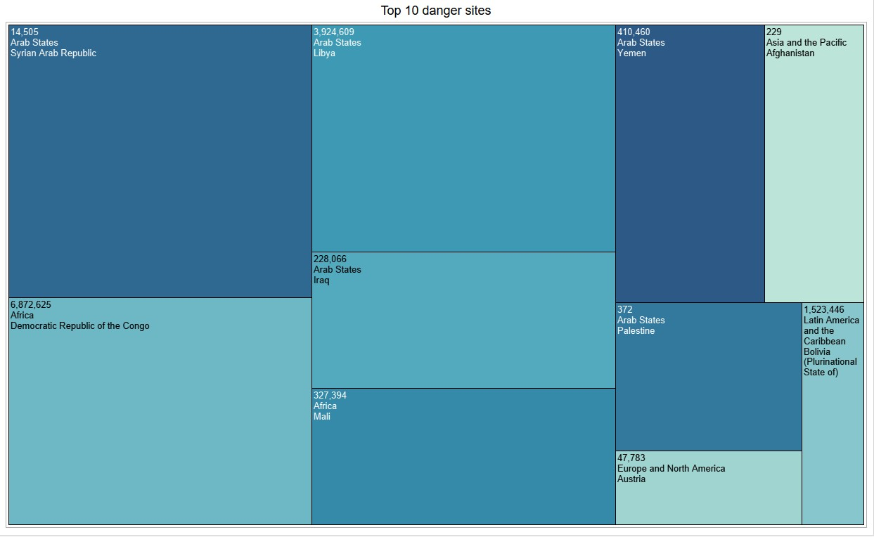

## Activity 1.5 : Year Forecasting of Heritages

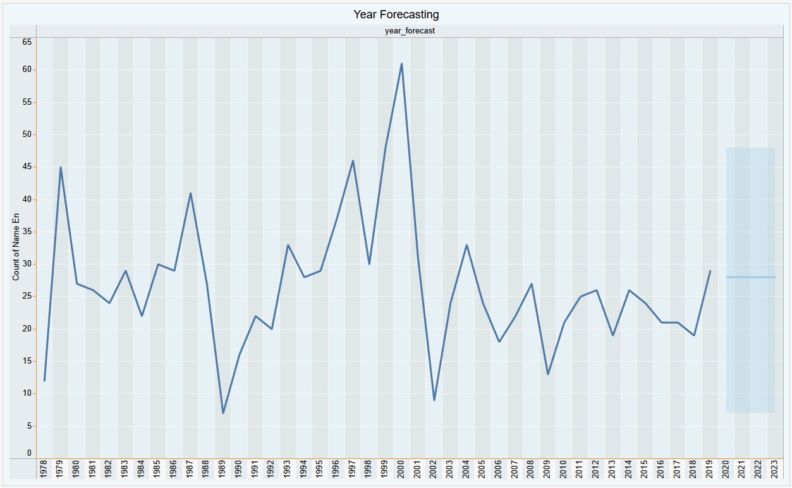

## Activity 1.6 : Categories by sites count

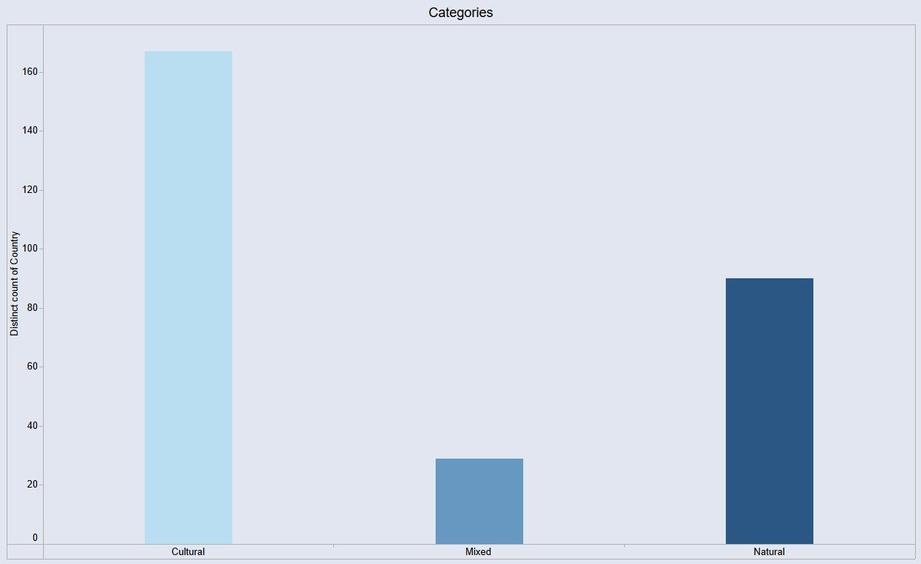

## Activity 1.7 : Site Count per Region

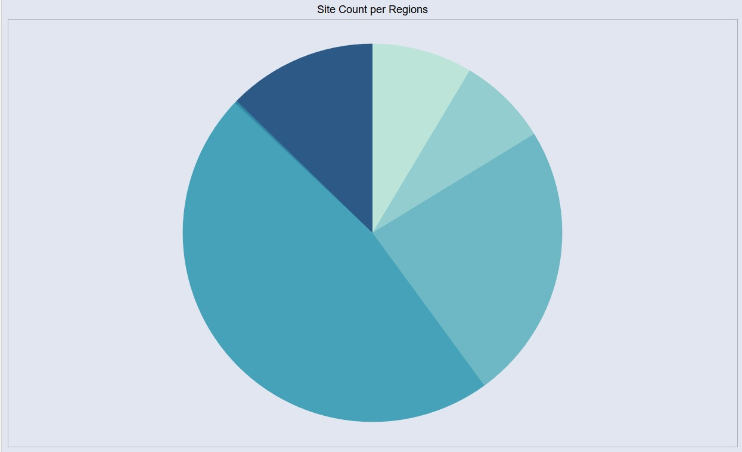

## Activity 1.8 : Analysis of Danger sites and Area of heritages

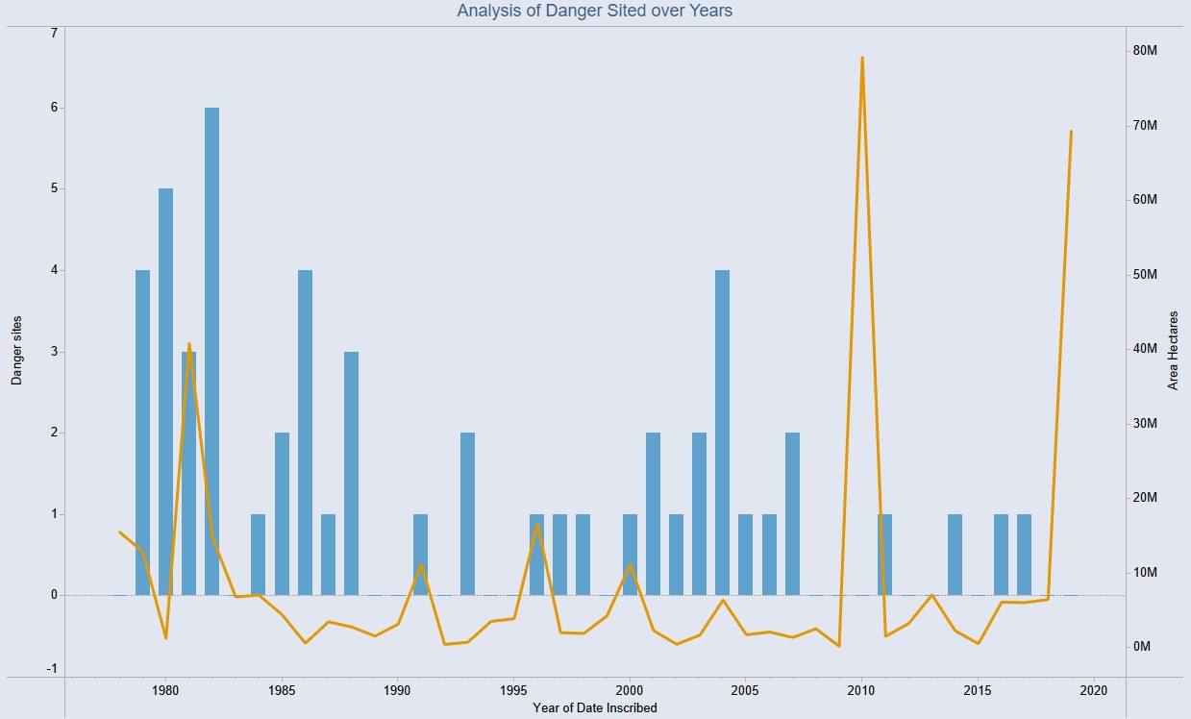

Note:All the above visualizations were explained in the link mentioned above.

# Dashboard

A dashboard is a graphical user interface (GUI) that displays information and data in an organized, easy-to-read format. Dashboards are often used to provide real-time monitoring and analysis of data and are typically designed for a specific purpose or use case. Dashboards can be used in a variety of settings, such as business, finance, manufacturing, healthcare, and many other industries. They can be used to track key performance indicators (KPIs), monitor performance metrics, and display data in the form of charts, graphs, and tables.

**Dashboard 1 Duration: 1 Hrs**

**Skill Tags:**

## Dashboard 1:UNESCO World Heritage Site Overview

**Link:** [**https://drive.google.com/file/d/1wjQb6BoHlfT3wyKEEBcMeSTBEzoHAmjk/view?usp =sharing**](https://drive.google.com/file/d/1wjQb6BoHlfT3wyKEEBcMeSTBEzoHAmjk/view?usp=sharing)

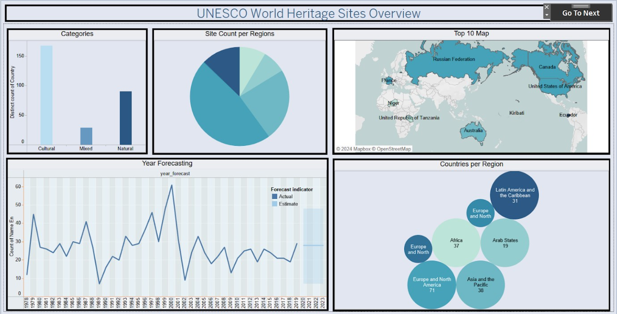

**Dashboard 2: Duration: 1 Hrs Skill Tags:**

**Dashboard 2:**

**Link:** [**https://drive.google.com/file/d/1PS7vZLeCV52n7hruFeN1IAHBJ8fTssUr/view?usp=sh aring**](https://drive.google.com/file/d/1PS7vZLeCV52n7hruFeN1IAHBJ8fTssUr/view?usp=sharing)

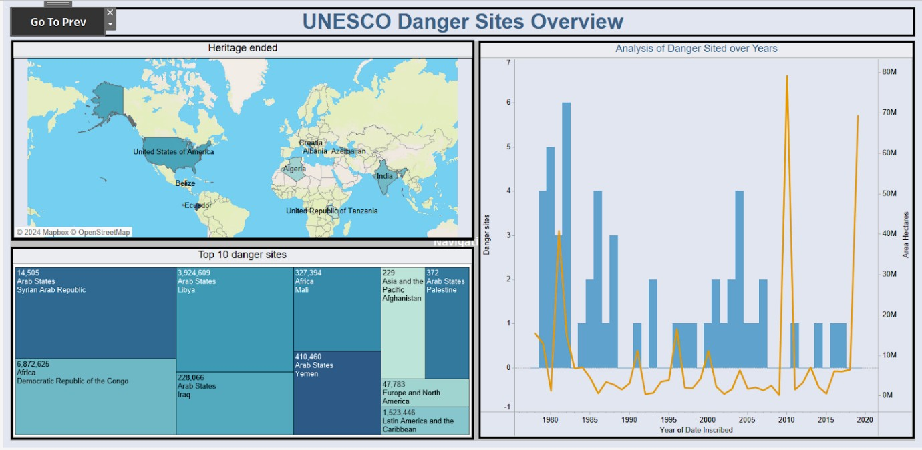

# Story

A data story is a way of presenting data and analysis in a narrative format, with the goal of making the information more engaging and easier to understand. A data story typically includes a clear introduction that sets the stage and explains the context for the data, a body that presents the data and analysis in a logical and systematic way, and a conclusion that summarizes the key findings and highlights their implications. Data stories can be told using a variety of mediums, such as reports, presentations, interactive visualizations, and videos. **No of Scenes of Story**

Duration: 1 Hrs

Skill Tags:

**No of Scenes of Story** <https://drive.google.com/file/d/1Y-iJ6gEo3B9TWWrGIZhxA_yWScEnSBdj/view?usp=sharing>

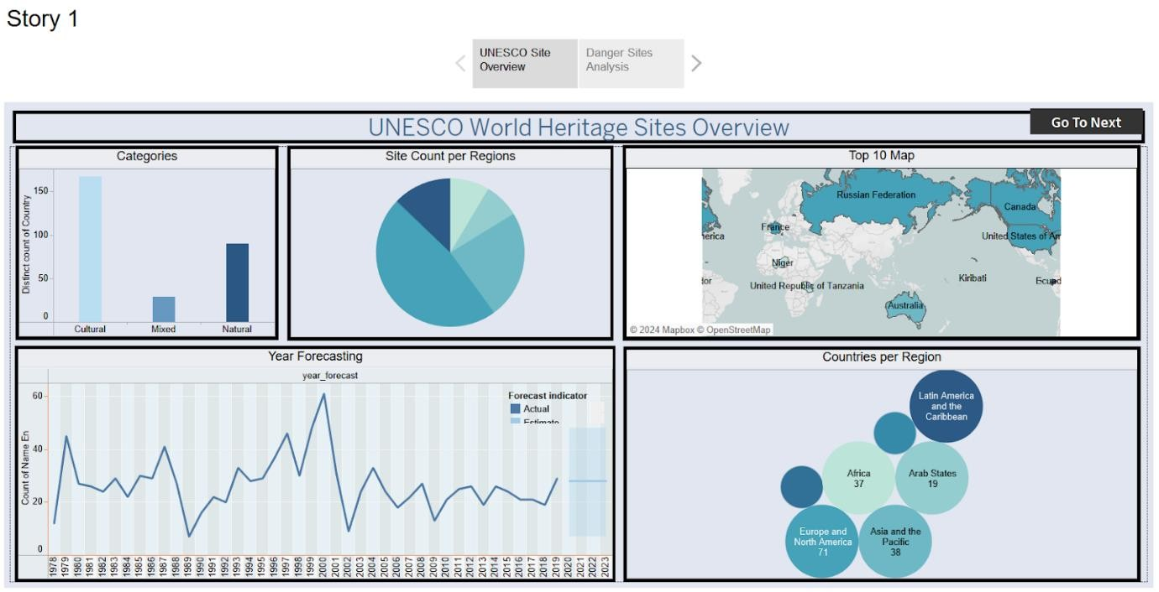

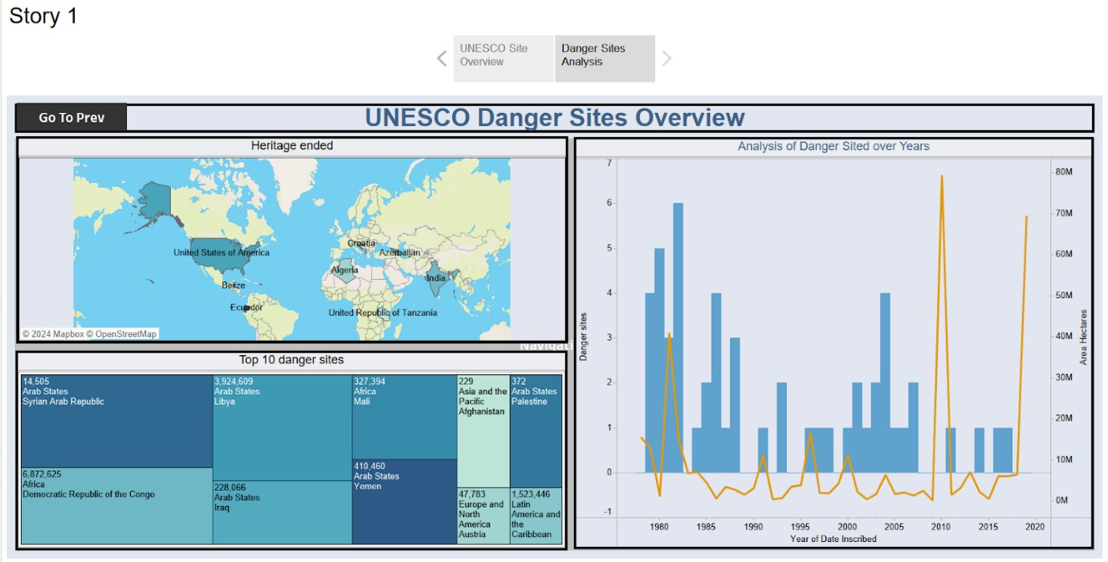

# Performance Testing

## Amount of Data Loaded

"Amount of Data Loaded" refers to the quantity or volume of data that has been imported, retrieved, or loaded into a system, software application, database, or any other data storage or processing environment. It's a measure of how much data has been successfully processed and made available for analysis, manipulation, or use within the system.

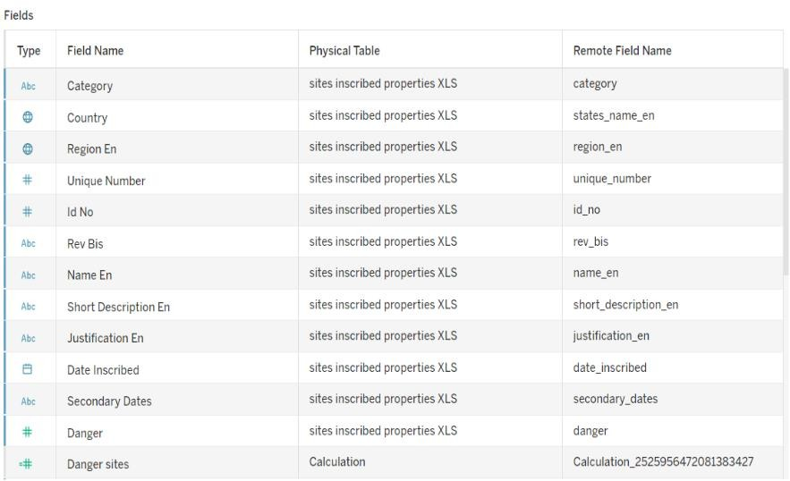

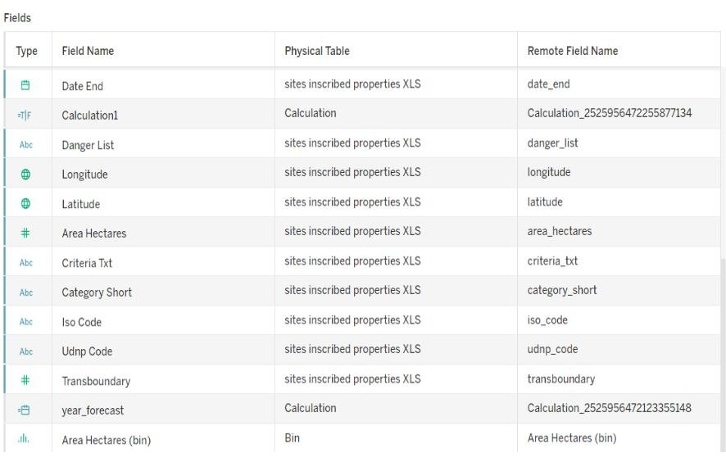

## Utilization of Data Filters

**Duration: 1 Hrs Skill Tags:**

"Utilization of Filters" refers to the application or use of filters within a system,software application, or data processing pipeline to selectively extract, manipulate, oranalyze data based on specified criteria or conditions

**Activity 2.1: Selected “Latin America” as a filter.**

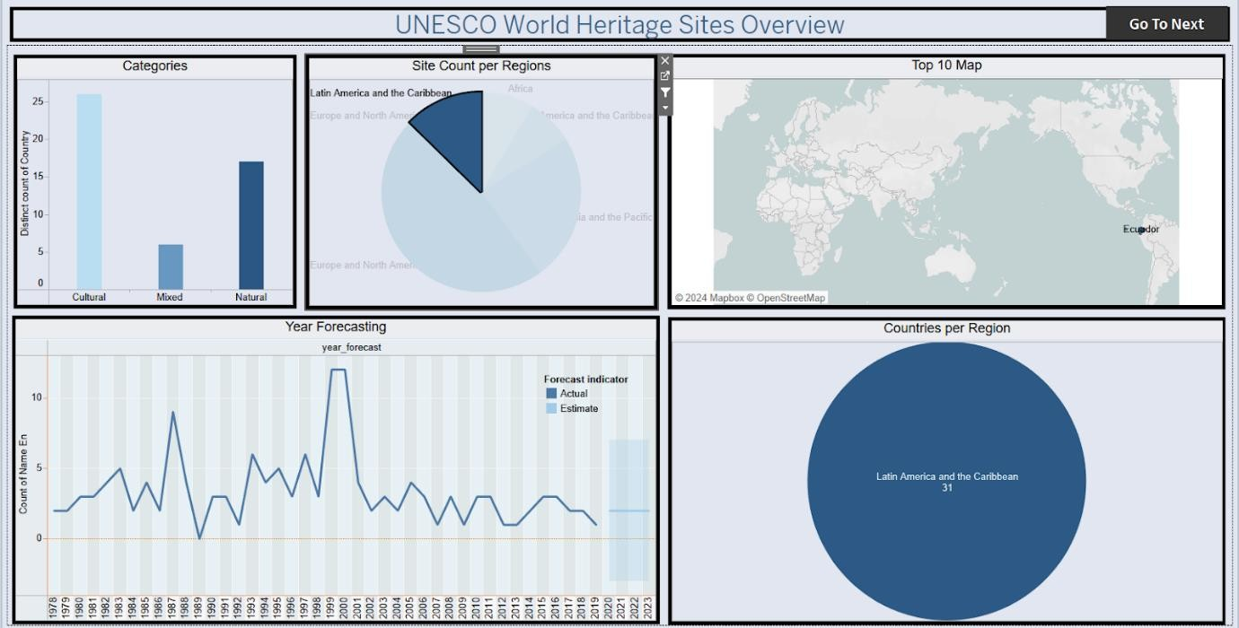

## Activity 2.2:Selected “Europe and North America‘’ as a filter

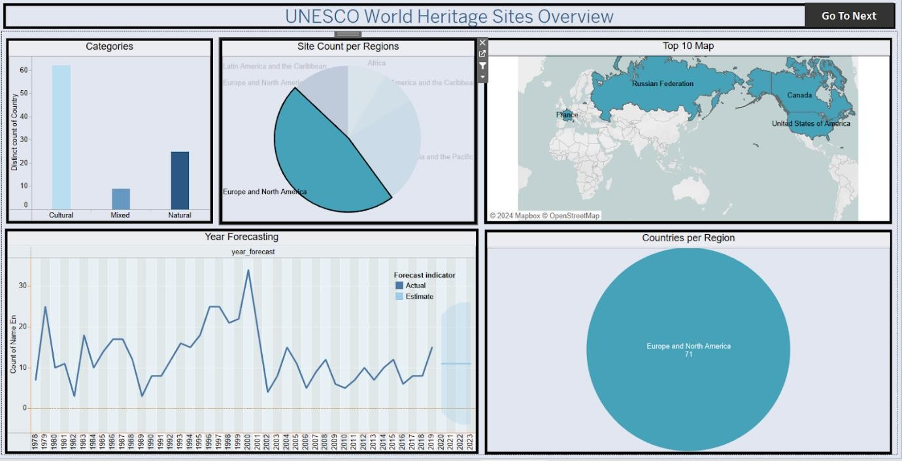

## No of Visualizations/ Graphs Duration: 0.5 Hrs

**Skill Tags:**

Top 10 regions by area

* Countries per Regions
* Sites Count per Region
* Analysis of Danger sites and Areas
* Heritage ended Regions
* Year Forecasting
* Categories by site count
* Top 10 danger sites

# Web integration

Publishing helps us to track and progress. help a publisher stay informed, make better decisions, and communicate their performance to Publishing helps us to track and monitor key performance metrics, to communicate results others. Publishing dashboard and reports to tableau public

## Go to Dashboard/story, click on share button on the top ribbon

Duration: 1 Hrs

Skill Tags:

Note:This process is also explained in the flask part mentioned below

Give the server address of your tableau public account and click on connect.

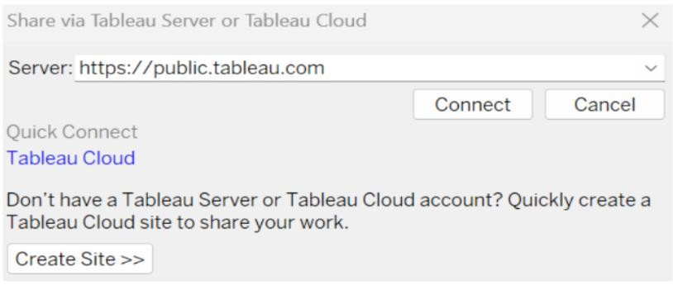

Step 2: Once you click on connect it will ask you for tableau public user name and password.

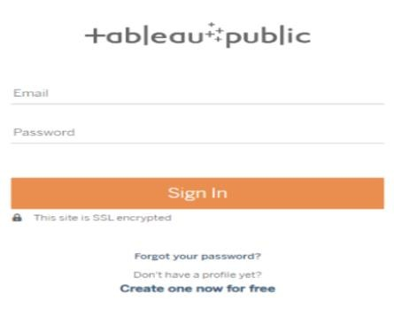

Once you login into your tableau public using the credentials, the particular visualization will be published into tableau public.

Note: While publishing the visualization to the public, the respective sheet will get published when you click on share option.

## Dashboard and Story embed with UI With Flask

Duration: 1 Hrs

Skill Tags:

Explanation video link:[TableauFlask.mp4](https://drive.google.com/file/d/1b0YdPMco1685SywHrOMTFx7MMYpZ-3RH/view?usp=sharing)

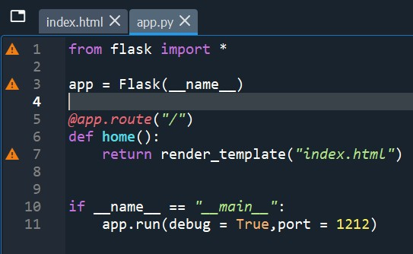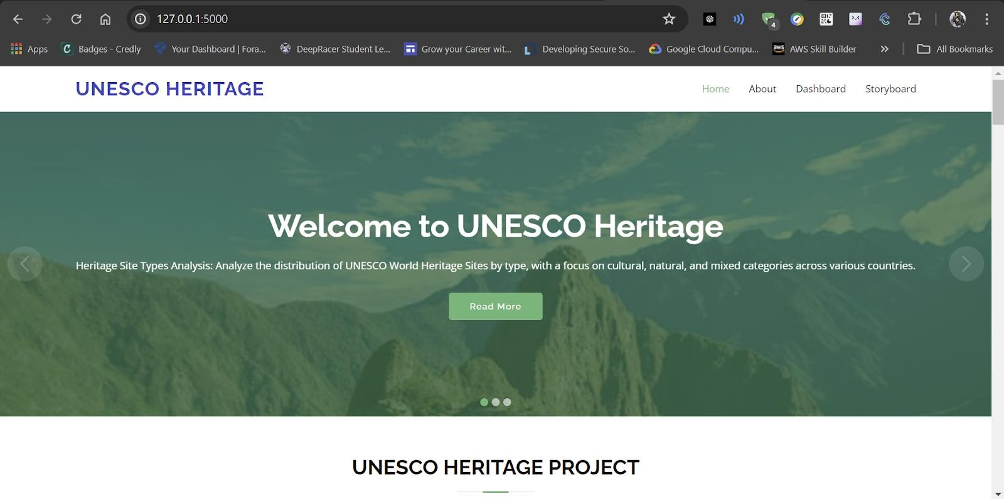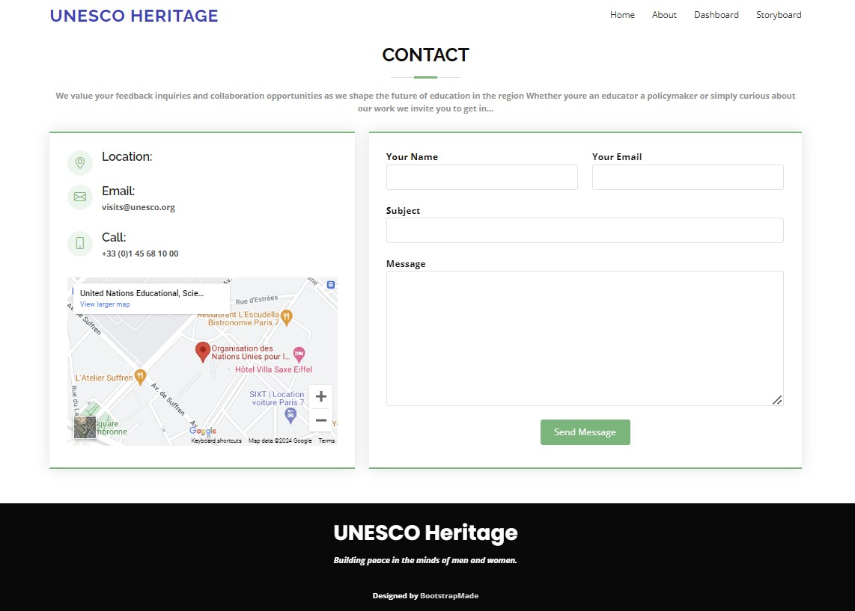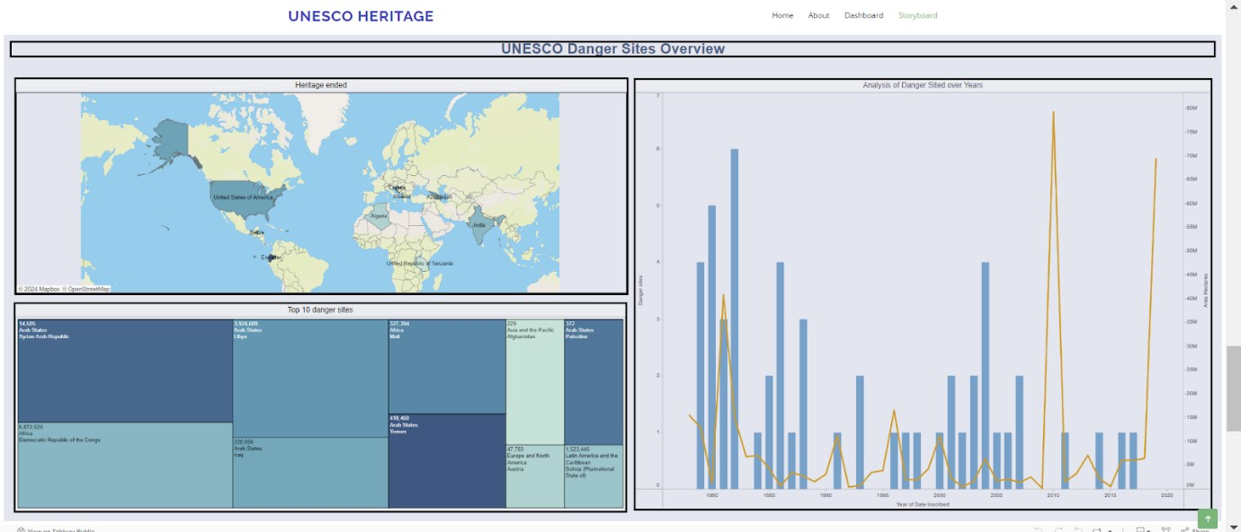

**Output:**

**Clean Data from Excel, CSV, PDF, and Google Sheets with Data Interpreter**

***Applies to: Tableau Cloud, Tableau Desktop, Tableau Server***

**When you track data in Excel spreadsheets, you create them with the human interface in mind. To make your spreadsheets easy to read, you might include things like titles, stacked headers, notes, maybe empty rows and columns to add white space, and you probably have multiple tabs of data too.**

**When you want to analyze this data in Tableau, these aesthetically pleasing attributes make it very difficult for Tableau to interpret your data. That’s where Data Interpreter can help.**

**Tip: Though Tableau's Excel add-in is no longer supported, Data Interpreter can help you reshape your data for analysis in Tableau.**

**What does Data Interpreter do?**

**Data Interpreter can give you a head start when cleaning your data. It can detect things like titles, notes, footers, empty cells, and so on and bypass them to identify the actual fields and values in your data set.**

**It can even detect additional tables and sub-tables so that you can work with a subset of your data independently of the other data.**

**After Data Interpreter has done its magic, you can check its work to make sure it captured the data that you wanted and identified it correctly. Then, you can make any necessary adjustments.**

**After you select the data that you want to work with, you might also need to do some additional cleaning steps like pivoting your data, splitting fields, or adding filters to get the data in the shape you want before starting your analysis.**

**Note: If your data needs more cleaning than what Data Interpreter can help you with, try**[**Tableau Prep(Link opens in a new window)**](https://www.tableau.com/products/prep)**.**

**Turn on Data Interpreter and review results**

1. **From the Connect pane, connect to an Excel spreadsheet or other connector that supports Data Interpreter such as Text (.csv) files, PDF files or Google sheets.**
2. **Drag a table to the canvas (if needed), then on the Data Source page, in the left pane, select the Use Data Interpreter check box to see if Data Interpreter can help clean up your data.**

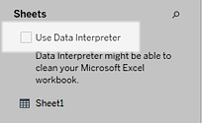

**Note: When you clean your data with Data Interpreter, Data Interpreter cleans all the data associated with a connection in the data source. Data Interpreter does not change the underlying data.**

1. **In the Data pane, click the Review the results link to review the results of the Data Interpreter.**

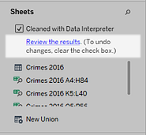

**A copy of your data source opens in Excel on the Key for the Data Interpreter tab. Review the key to find out how to read the results.**

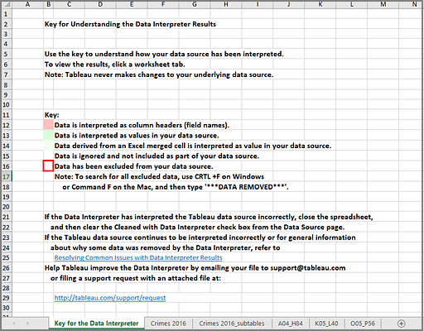

1. **Click each tab to review how Data Interpreter interpreted the data source.**

**If Data Interpreter found additional tables, also called found tables or sub-tables, they are identified in the <sheet name>_subtables tab by outlining their cell ranges. A separate tab is also included for each sub-table, color coded to identify the header and data rows.**

**If Data Interpreter does not provide the expected results, clear the Cleaned with Data Interpreter check box to use the original data source.**

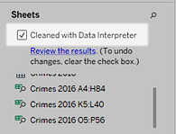

1. **To replace the current table with any of the found tables, drag the current table off the canvas and then drag the found table that you want to use to the canvas.**

**If Data interpreter has misidentified the range of the found table, after you drag the found table to the canvas, click the drop-down arrow on that table, and then select Edit Found Table to adjust the corners of the found table (the top-left cell and bottom-right cell of the table).**

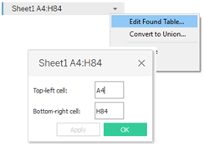

1. **After you have the data that you want to work with, you can apply any additional cleaning operations to your data so that you can analyze it.**

**Data Interpreter Example**

**In this example we are connecting to an Excel spreadsheet with violent crime data by city and state for the year 2016. This spreadsheet includes multiple tables on one sheet and some extra formatting.**

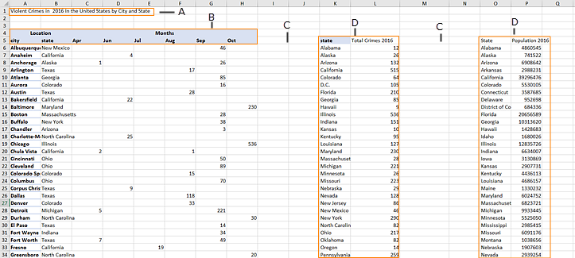

1. **Title**
2. **Merged header cells**
3. **Extra white space**
4. **Sub-tables**

**The extra formatting in this spreadsheet makes it difficult for Tableau to determine what the field headers and values are.**

**Instead, it reads the data vertically and assigns each column the default value F1, F2, F3 (Field 1, Field 2, Field 3) and so on. Blank cells are read as null values.**

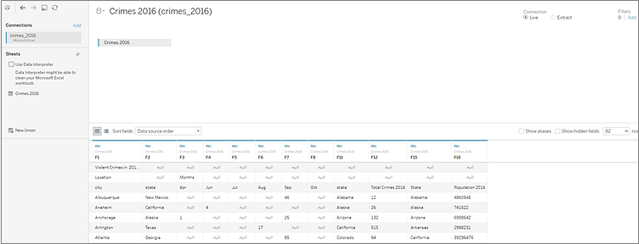

**To see if Data Interpreter can help clean this data set, we select Use Data Interpreter.**

**Data Interpreter detected the proper headings for the fields, removed the extra formatting and found several sub-tables. The sub-tables are listed in the Sheets section in the Data pane and are named using the original sheet name and the cell ranges for each sub-table.**

**In this example there are three sub-tables: Crimes 2016 A4:H84, Crimes 2016 K5:L40, and Crimes 2016 O5:P56.**

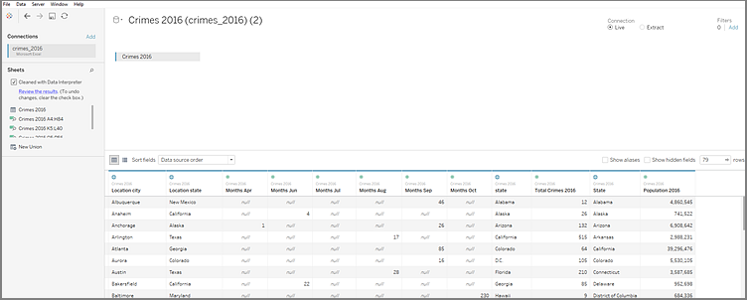

**To examine the results of the Data Interpreter more closely, we click the Review the results link in the Data pane to view an annotated copy of the spreadsheet.**

**Here we see a copy of the original data, color coded to identify which data was identified as header data and which data was identified as field values.**

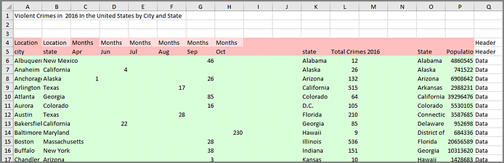

**The next tab shows us the sub-tables that Data Interpreter found, outlined by the cell ranges.**

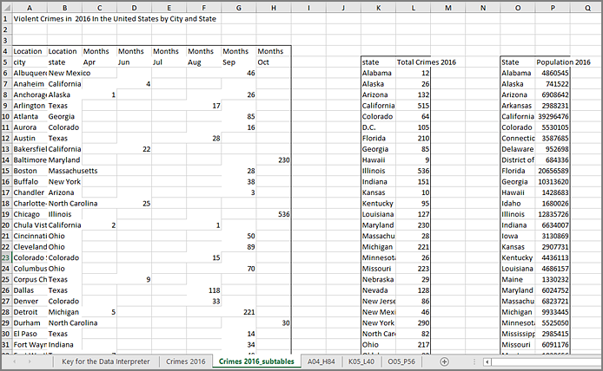

**In this example the first sub-table, Crimes 2016 A4:H84, has the main data that we want to work with. To use this table as our data table, we can simply drag the original table off the canvas and then drag the new table to the canvas.**

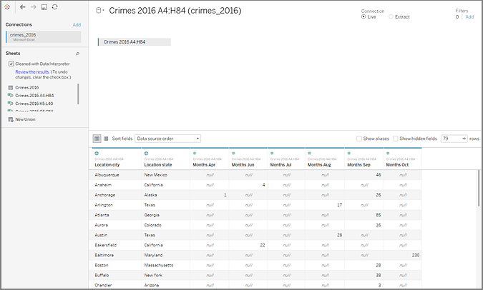

**Once we have the data that we want to work with in the canvas, we can do some additional clean up on the data. For example we can:**

* **Change the field names so that they represent city, state, and month names.**
* **Pivot the months fields.**
* **Drag in the third sub-table Crimes 2016 o5:P56 and join it to our first sub-table on the State field to include state populations for our analysis.**
* **Hide any duplicate fields that were added as a result of the join.**

**The results might look something like this:**

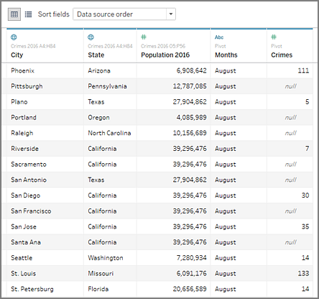

**Now we are ready to start analyzing our data in Tableau.**

**When Data Interpreter is not available**

**The Data Interpreter option might not be available for the following reasons:**

* **The data source is already in a format that Tableau can interpret: If Tableau Desktop doesn't need extra help from Data Interpreter to handle unique formatting or extraneous information, the Data Interpreter option is not available.**
* **Many rows or many columns: The Data Interpreter option is not be available when your data has the following attributes:**
  + **Data contains more than 2000 columns.**
  + **Data contains more than 3000 rows and more than 150 columns.**
* **The data source is not supported: Data Interpreter is only available for Microsoft Excel, Text (.csv) files, PDF files and Google Sheets. For Excel, your data must be in the .xls or .xlsx format.**